Batch: C-3 Roll No.: 16010123217

Experiment No.___7__

Grade: AA / AB / BB / BC / CC / CD /DD

Signature of the Staff In-charge with date

Title:Study, Implementation, and Analysis of 0/1 Knapsack Problem.

Objective: To learn 0/1 Knapsack Problem using Dynamic Programming Approach. (Maximize the total value of selected items while ensuring their total weight does not exceed W.)
CO to be achieved:
CO 2 | Describe various algorithm design strategies to solve different problems and analyse Complexity.

Books/ Journals/ Websites referred:
- Ellis horowitz, Sarataj Sahni, S.Rajsekaran,” Fundamentals of computer algorithm”, University Press
- T.H.Cormen ,C.E.Leiserson,R.L.Rivest and C.Stein,” Introduction to algortihtms”,2nd Edition ,MIT press/McGraw Hill,2001
- http://www.lsi.upc.edu/~mjserna/docencia/algofib/P07/dynprog.pdf
- http://www.geeksforgeeks.org/travelling-salesman-problem-set-1/
- http://www.mafy.lut.fi/study/DiscreteOpt/tspdp.pdf
- https://class.coursera.org/algo2-2012-001/lecture/181
- http://www.quora.com/Algorithms/How-do-I-solve-the-travelling-salesman-problem-using-Dynamic-programming
- www.cse.hcmut.edu.vn/~dtanh/download/Appendix_B_2.ppt
- www.ms.unimelb.edu.au/~s620261/powerpoint/chapter9_4.ppt‎

Pre Lab/ Prior Concepts:
Data structures, Concepts of algorithm analysis

Historical Profile:
Dynamic Programming (DP) is used heavily in optimization problems (finding the maximum and the minimum of something). Applications range from financial models and operation research to biology and basic algorithm research. So the good news is that understanding DP is profitable. However, the bad news is that DP is not an algorithm or a data structure that you can memorize. It is a powerful algorithmic design technique.
The 0/1 Knapsack Problem is one of the most studied problems in computer science, operations research, and combinatorial optimization. Its origins and development reflect the evolution of mathematical optimization and computational techniques.
Historical Background
Origins in Resource Allocation:The knapsack problem has its roots in resource allocation problems dating back centuries, where individuals needed to maximize their gain (value) from limited resources (capacity).The term "knapsack" derives from the idea of filling a knapsack with items to achieve the greatest benefit without exceeding its weight limit.
Early Formalization: The problem was first mathematically formalized in the early 20th century as part of broader studies in combinatorics and optimization. It gained attention as a theoretical challenge in discrete mathematics.
Greedy Algorithms and Limitations:Researchers also explored greedy approaches for simplified variants (e.g., fractional knapsack).The greedy algorithm does not work for the 0/1 knapsack problem due to its inability to handle binary choices optimally.

New Concepts to be learned:
Application of algorithmic design strategy to any problem, dynamic Programming method of problem solving Vs other methods of problem solving, optimality of the solution, Optimal Binary Search Tree Problems and their applications

Algorithm:
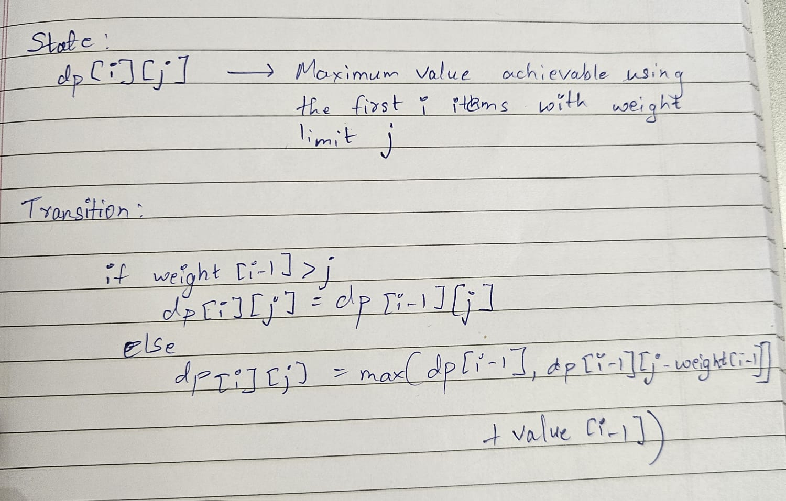
Example:
Number of items: n = 3
Knapsack capacity: w = 8
Weights: [3, 4, 5]
Values: [30, 50, 60]

DP Table:
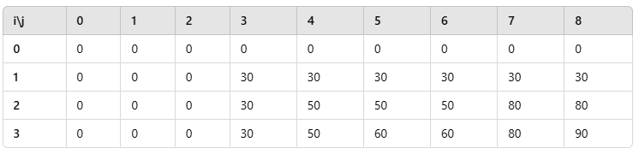
Answer:
Maximum value that can be obtained with weight limit 8 is 90

Code:
#include <bits/stdc++.h>

using namespace std;

int main(){
cout<<"Enter ther number of values and max weight:\t";
int n, w; cin>>n>>w;
vector<int> value(n), weight(n);
cout<<"Enter the weights:\n";
for(auto &i: weight) cin>>i;
cout<<"Enter the values:\n";
for(auto &i: value) cin>>i;

vector<vector<int>> dp(n+1, vector<int> (w+1, 0));

for(int i=1; i<=n; i++){
for(int j=0; j<=w; j++){

dp[i][j] = dp[i-1][j];

if(weight[i-1] <= j){
dp[i][j] = max(dp[i][j], dp[i-1][j-weight[i-1]] + value[i-1]);
}

}
}

cout <<"Maximum profit:\t"<<dp[n][w] << '\n';
return 0;
}

Output:
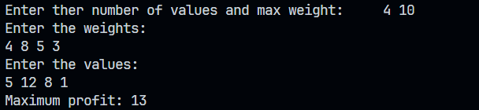

Analysis of algorithm:
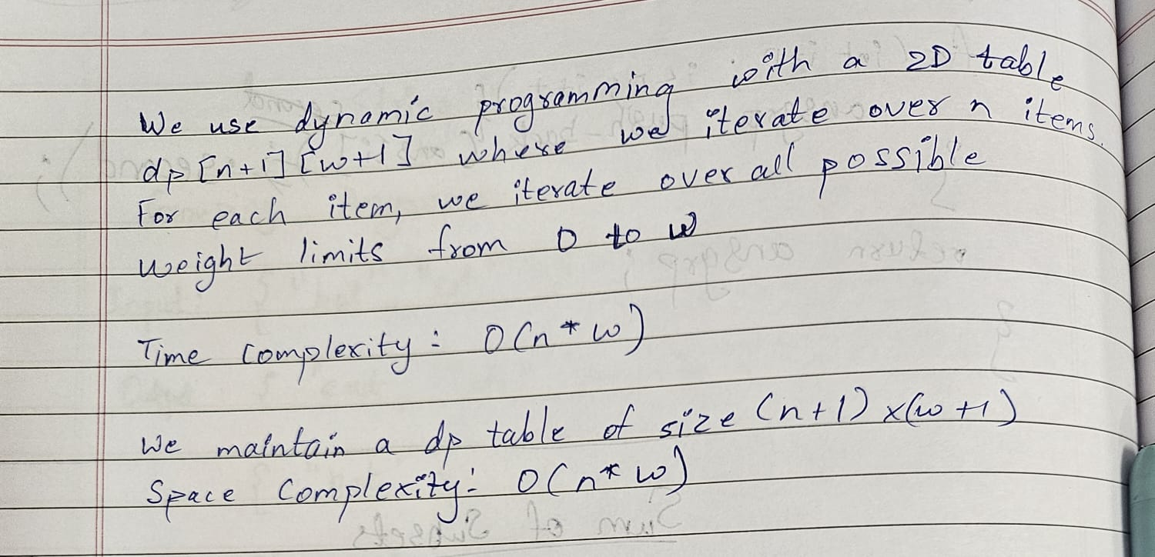

CONCLUSION: We learnt how to use dynamic programming to solve the 0-1 knapsack problem efficiently.

